**D2 – evaluate the tools and techniques used to create animations**

**Introduction**

In this task I will evaluate the tools and techniques used to create animation. I will create an evaluation which considers:

* Ease of use
* Technical aspects of the animation
* Limitations of the software you used
* The appearance of the animation
* How you met the target file size

**Ease of use**

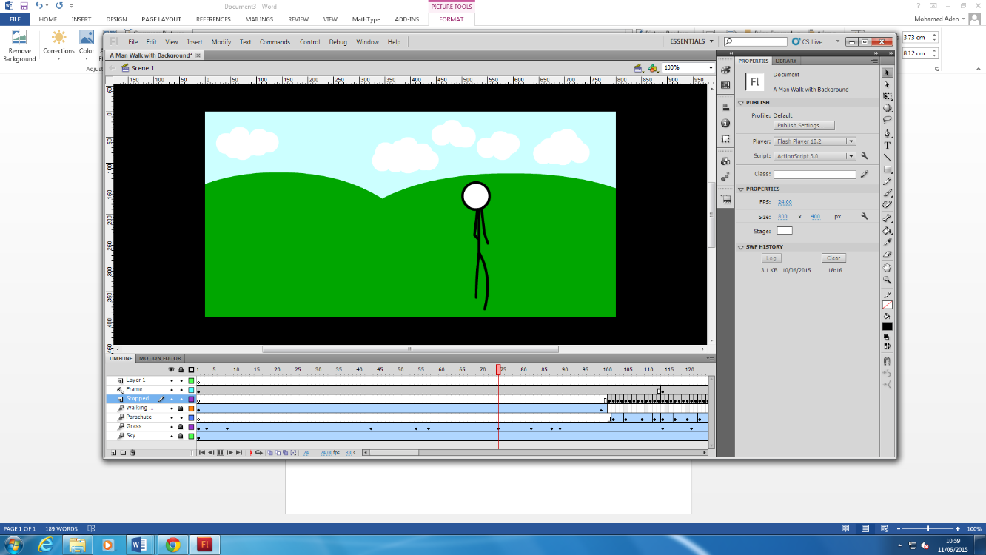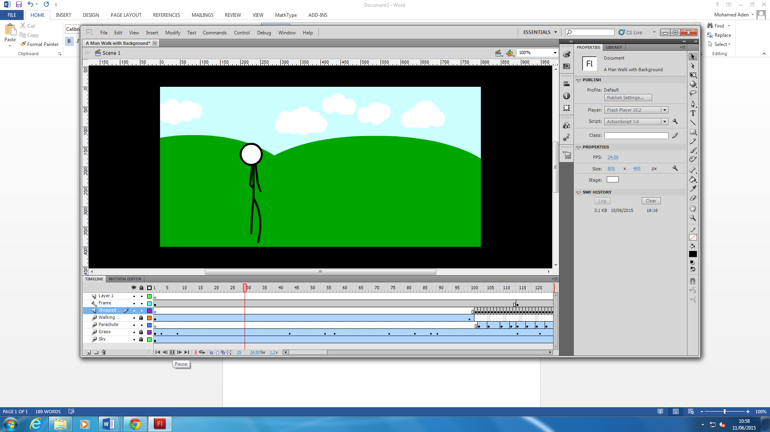An expected benefit of animation is improved ease of use. With easy access to different and basic software’s that could be used for creating animation. Such as Adobe Flash. It doesn’t take a smart person to manoeuvre the application. The animation we created was used in the software Adobe Flash and the software itself had many tools in our disposal such as the code snippets. The good things about flash is that it’s an easy software so that you can easily make an animation very fast. Another advantage of flash is that it is easy to learn and that anybody can operate the software easily. One technique we used is the motion tweens and these where used when the main character was running from one end to another.

**Technical aspects of the animation**

When speaking aspects of animation you will definitely need to a computer that runs the particular software which is Flash. The computer must run the Flash software quickly and effectively the animation we made was also saved under a PDF document which is very handy since it can be played through that software. The flash had many problems when we were creating the animation flash is that the file size is large so you can really make many files. So we avoided this by making our animation very small in size so it doesn’t become slow at all. Also the file size can be corrupted very easily so we totally avoided it.

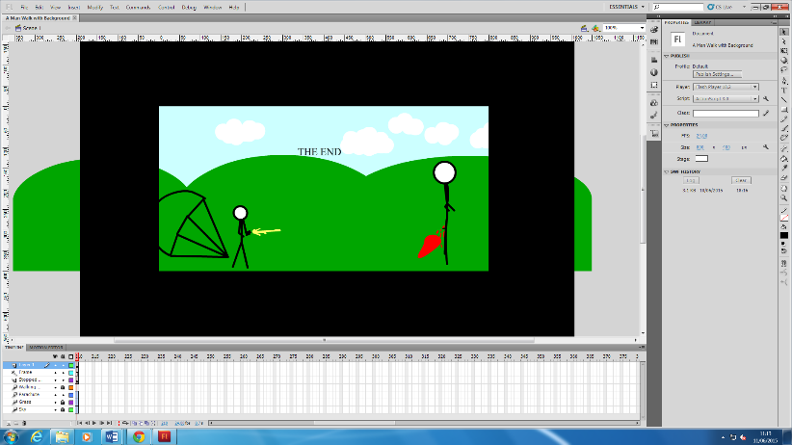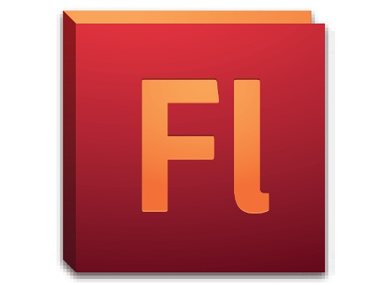

**Limitations of the software you used**

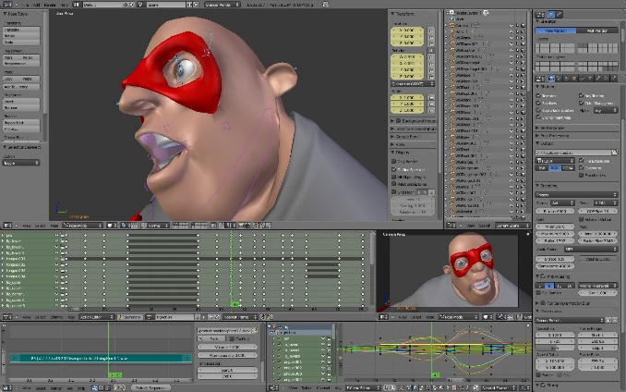There are many limitation using the software we used which was Adobe Flash. As I said earlier the flash when we were creating the animation flash is that the file size is large so you can really make many files. So we avoided this by making our animation very small in size so it doesn’t become slow at all. Also the file size can be corrupted very easily so we totally avoided it. Also the Flash software isn’t really specialist meaning that the software won’t include complex tools and techniques needed. In the animation industry the employee wouldn’t go near flash since it is called an amateur type of software and they will opting to the other software such as Maya and Blender which both use virtualized 3D animation as seen below.

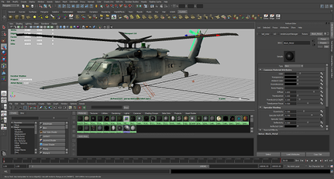

**The appearance of the animation**

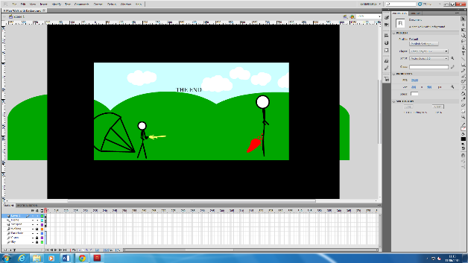The appearance of the animation is very important, if it doesn’t have good appearance then it wouldn’t be classed as a professional animation at all. We didn’t really focus on the appearance side of things but we did give a bit of attention since it important. We added good background which actually complimented the inner things within the animation. The tools we used helped a lot since if we didn’t use the particular tools in the right place then the animation wouldn’t actually look good. Since we used the software which is isn’t really basic we had to the best we got to make our animation look better. We also made it look better since we putted the frames much faster and slicker.

**How you met the target file size**

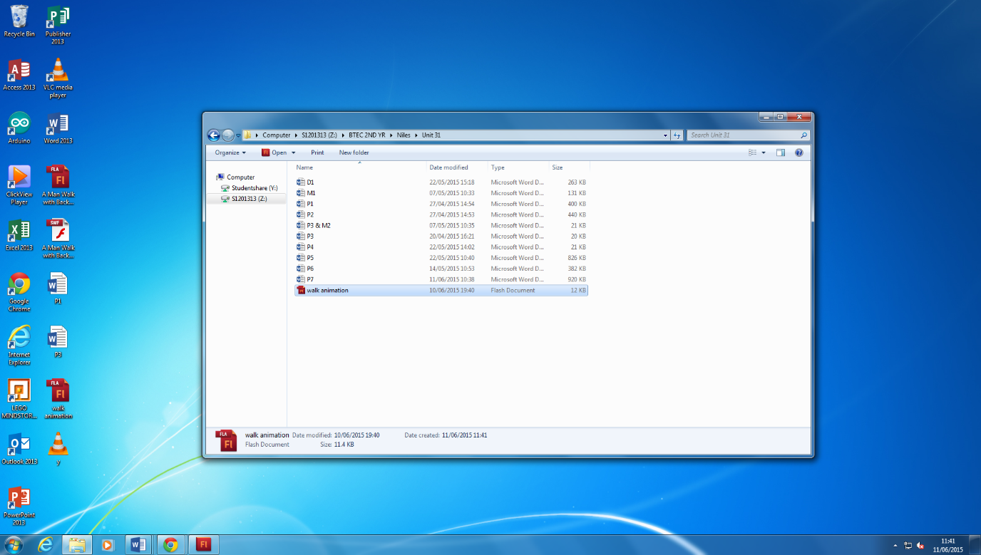We had to meet the target size by making our animation short but effective. If we didn’t make it short and instead made longer the flash software file size would be large so you can’t really make many files. So we avoided this by making our animation very small in size so it doesn’t become slow at all. Also the file size can be corrupted very easily so we totally avoided it

**Conclusion**

In conclusion we had to do many things while making the animation and this made us as individual more wary of the fact we are getting better at animation as whole. One thing that I will change is to try to make the animation better look it at. We should of done a real person instead of a stick figure since it is much more professional.